EMPLOYEE MANAGEMENT SYSTEM

CRUD-BASED WEB APPLICATION

Project Documentation
Technologies: HTML, CSS, JavaScript, Django, Django REST Framework, SQLite
Testing: Postman
Version Control: Git & GitHub
EMPLOYEE MANAGEMENT SYSTEM
CRUD-BASED WEB APPLICATION
PROJECT DOCUMENTATION
Technologies Used: HTML, CSS, JavaScript, Django, Django REST Framework, SQLite
API Testing: Postman
Version Control: Git & GitHub
Development Tool: Visual Studio Code

1. PROJECT TITLE
Employee Management System
The Employee Management System is a CRUD-based web application developed to manage employee information digitally.
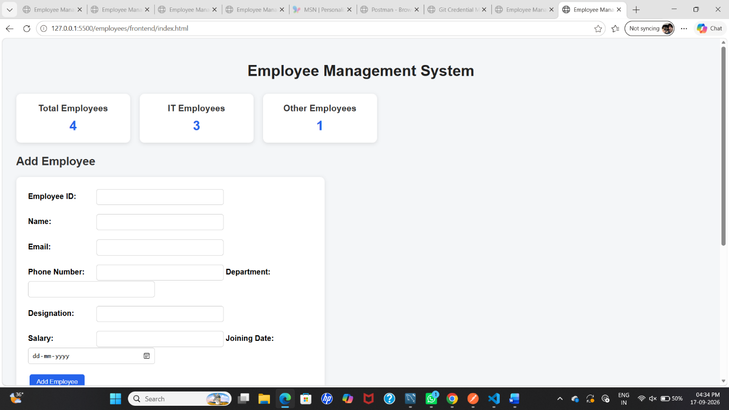

2. INTRODUCTION
Employee Management System is a web-based application designed to manage employee records efficiently. In traditional systems, employee information may be maintained manually, which can make searching, updating, and maintaining records difficult.
This application provides a simple interface through which users can add employee details, view employee records, search for employees, update employee information, and delete employee records.
The frontend of the application is developed using HTML, CSS, and JavaScript. Django and Django REST Framework are used to develop the backend REST API. SQLite is used to store employee information.
The application follows CRUD operations:
- Create – Add a new employee
- Read – View employee information
- Update – Modify employee information
- Delete – Remove employee information
Postman is used to test the REST API operations, while Git and GitHub are used for version control and project hosting.

3. OBJECTIVES
The main objectives of the Employee Management System are:
- To maintain employee details digitally.
- To perform CRUD operations on employee records.
- To provide a simple and user-friendly interface.
- To store employee information in a database.
- To connect the frontend with the backend using REST API.
- To provide search functionality for employee records.
- To validate basic employee information.
- To test REST API operations using Postman.
- To use Git and GitHub for project version control.
- To demonstrate a complete full-stack web application.

4. TECHNOLOGIES USED
Technology | Purpose
HTML | Creates the structure of the webpage
CSS | Provides styling and layout
JavaScript | Handles frontend functionality and API communication
Python | Programming language used for backend development
Django | Backend web framework
Django REST Framework | Creates REST APIs
SQLite | Stores employee records
Postman | Tests API operations
Git | Version control
GitHub | Project hosting and source-code management
VS Code | Development environment

5. EMPLOYEE DETAILS
The application stores the following employee information:
Field | Description
Employee ID | Unique identification number of the employee
Name | Name of the employee
Email | Employee email address
Phone | Employee phone number
Department | Department in which the employee works
Designation | Job position of the employee
Salary | Salary of the employee
Joining Date | Date on which the employee joined
These details are stored in the SQLite database and can be accessed through the REST API.

6. SYSTEM REQUIREMENTS
6.1 Hardware Requirements
- Computer or Laptop
- Minimum 4 GB RAM
- Keyboard and Mouse
- Internet connection
6.2 Software Requirements
- Windows Operating System
- Python
- Django
- Django REST Framework
- Visual Studio Code
- Postman
- Git
- Web Browser

7. SYSTEM ARCHITECTURE
The Employee Management System follows a simple three-layer architecture.
USER
|
↓
FRONTEND APPLICATION
HTML + CSS + JavaScript
|
↓
REST API
Django + Django REST Framework
|
↓
DATABASE
SQLite
Explanation
The user interacts with the frontend application through a web browser.
The frontend is created using HTML, CSS, and JavaScript. JavaScript sends requests to the Django REST API.
Django processes the requests and communicates with the SQLite database.
The database stores employee records and sends the requested information back to the backend. The backend then sends the response to the frontend.

8. HOW THE SYSTEM WORKS
The working process of the system is as follows:
- The user opens the Employee Management System in a web browser.
- The user enters employee information in the Add Employee form.
- JavaScript collects the entered information.
- JavaScript sends the employee data to the Django REST API.
- Django processes the request.
- The employee information is stored in the SQLite database.
- The employee list displays the stored information.
- The user can search for an employee.
- The user can update employee information using the Edit option.
- The user can remove an employee using the Delete option.

9. FRONTEND DESIGN
The frontend is developed using HTML, CSS, and JavaScript.
The main frontend features are:
9.1 Dashboard
The dashboard displays:
- Total Employees
- IT Employees
- Other Employees
The dashboard gives a quick overview of the employee records.
9.2 Add Employee Form
The Add Employee form allows the user to enter:
- Employee ID
- Name
- Email
- Phone
- Department
- Designation
- Salary
- Joining Date
9.3 Employee List
The Employee List displays all employee records in a table.
The table contains employee details and action buttons.
9.4 Search
The search box allows users to search employees using Employee ID or Name.
9.5 Edit
The Edit button allows the user to modify employee information.
9.6 Delete
The Delete button removes an employee record from the database.

10. BACKEND DEVELOPMENT
The backend is developed using Python and Django.
Django REST Framework is used to create REST APIs.
The major backend components are:
10.1 Model
The Employee model defines the fields stored in the database.
The model contains:
- employee_id
- name
- email
- phone
- department
- designation
- salary
- joining_date
10.2 Serializer
The serializer converts database objects into JSON format and converts JSON data received from the frontend into data that can be processed by Django.
10.3 ViewSet
The Employee ViewSet handles CRUD operations.
It provides functionality for:
- Creating employees
- Retrieving employees
- Updating employees
- Deleting employees
10.4 URL Router
The URL router connects the API endpoint with the Employee ViewSet.

11. DATABASE DESIGN
SQLite is used as the database for this project.
The Employee table contains the following fields:
Field | Data Type
ID | Integer
Employee ID | Character
Name | Character
Email | Email
Phone | Character
Department | Character
Designation | Character
Salary | Decimal
Joining Date | Date
The Employee ID is unique so that duplicate employee IDs cannot be added.

12. CRUD OPERATIONS
CRUD stands for:
C – Create
R – Read
U – Update
D – Delete
The application implements all four CRUD operations.
Operation | HTTP Method | API Endpoint
Create | POST | /api/employees/
Read | GET | /api/employees/
Update | PUT/PATCH | /api/employees/{id}/
Delete | DELETE | /api/employees/{id}/

13. CREATE OPERATION – POST
The POST operation is used to add a new employee.
The user enters employee information through the frontend form or sends JSON data through Postman.
Example:
{
"employee_id": "EMP005",
"name": "Meena",
"email": "meena@gmail.com",
"phone": "9876543211",
"department": "IT",
"designation": "Tester",
"salary": 30000,
"joining_date": "2026-09-17"
}
After sending the request, Django stores the employee information in the SQLite database.
Result: New employee was added successfully.

14. READ OPERATION – GET
The GET operation is used to retrieve employee records.
API endpoint:
/api/employees/
The API returns employee information in JSON format.
The GET operation was tested successfully using Postman.
Result: Employee list was retrieved successfully.
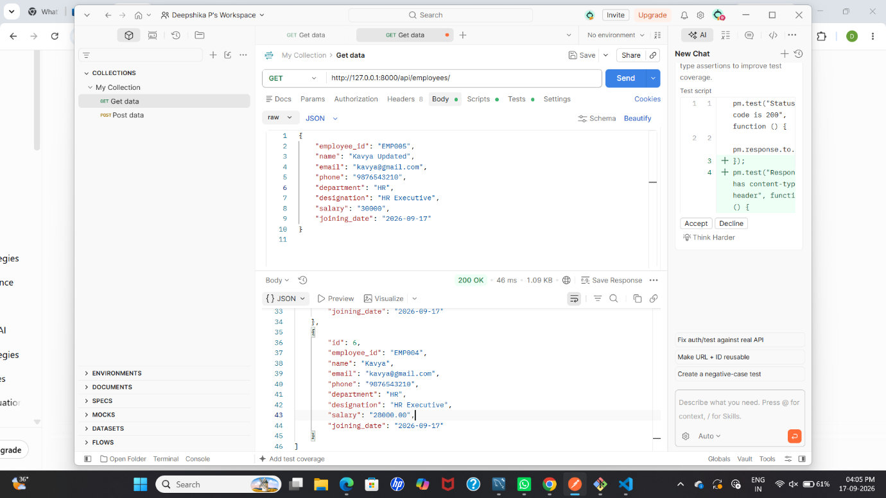

15. UPDATE OPERATION – PUT/PATCH
The PUT or PATCH operation is used to modify employee information.
For example, the employee name can be changed from:
Meena
to:
Meena Updated
The employee designation and salary can also be modified.
Result: Employee information was updated successfully.
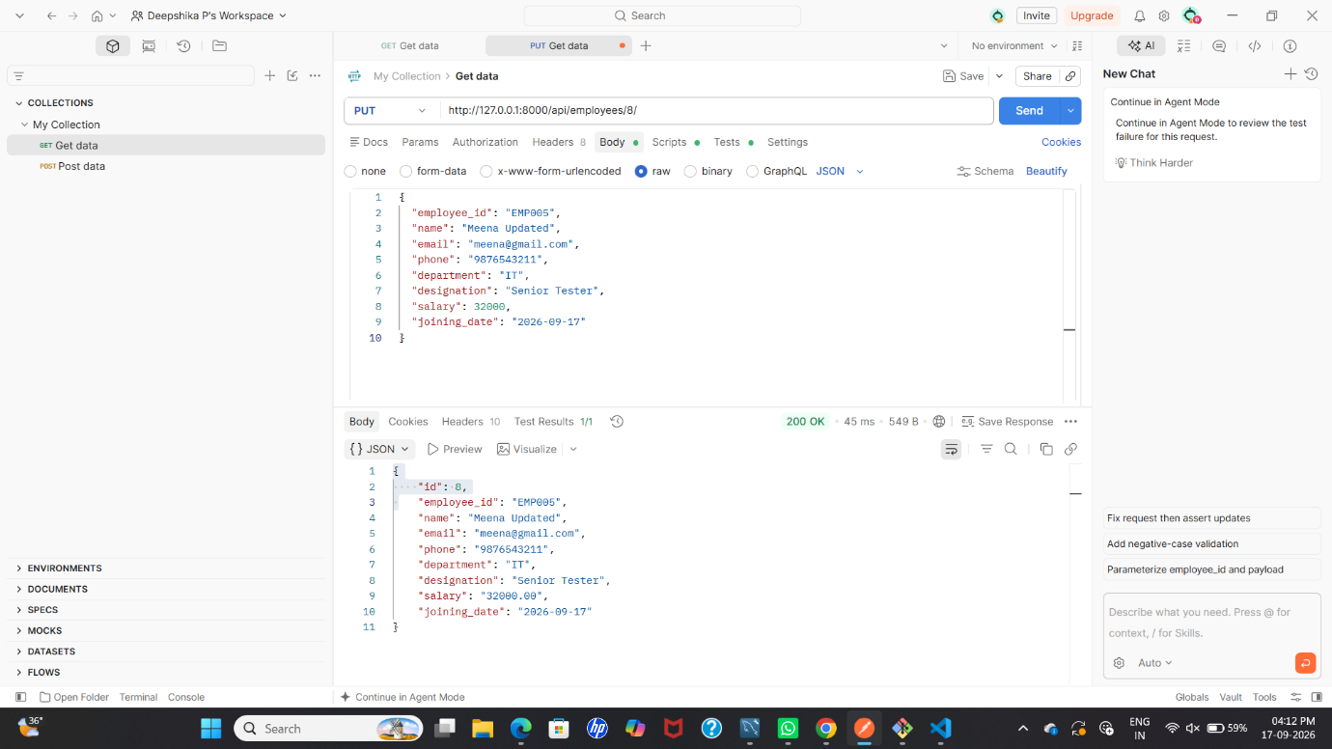

16. DELETE OPERATION
The DELETE operation is used to remove an employee record.
The employee ID is included in the API endpoint.
Example:
/api/employees/8/
After the DELETE request is processed, the selected employee record is removed from the database.
Result: Employee record was deleted successfully.

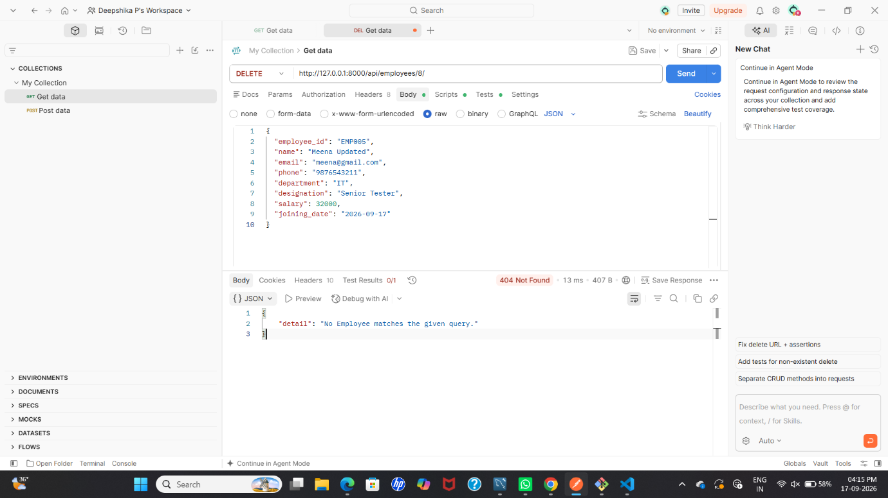

17. VALIDATION
Basic validation is implemented in the application.
The validation includes:
- Required employee fields
- Valid email format
- 10-digit phone number
- Salary value
- Unique Employee ID
- Valid joining date
Validation helps prevent incorrect information from being entered into the system.

18. SEARCH FUNCTION
The application provides a search feature.
Users can search employee records using:
- Employee ID
- Employee Name
JavaScript compares the entered search text with the employee ID and employee name displayed in the table.
Matching records are displayed while non-matching records are hidden.
This makes it easier to locate a particular employee when many records are available.

19. API TESTING USING POSTMAN
Postman was used to test the REST API.
The following operations were tested:
GET
Used to retrieve the list of employees.
POST
Used to add a new employee.
PUT/PATCH
Used to update employee information.
DELETE
Used to remove an employee.
All four CRUD operations were tested during the project.

20. PROJECT FLOW
START
|
↓
Open Employee Management System
|
↓
Enter Employee Details
|
↓
JavaScript Sends API Request
|
↓
Django REST API
|
↓
SQLite Database
|
↓
Employee Data Stored/Retrieved
|
↓
Display Employee List
|
↓
Search / Update / Delete
|
↓
END

21. TESTING SCREENSHOTS
Figure 1 – Frontend Employee Management System
The screenshot shows the Employee Management System interface with dashboard, Add Employee form, search option, and employee list.

Figure 2 – GET Employee List
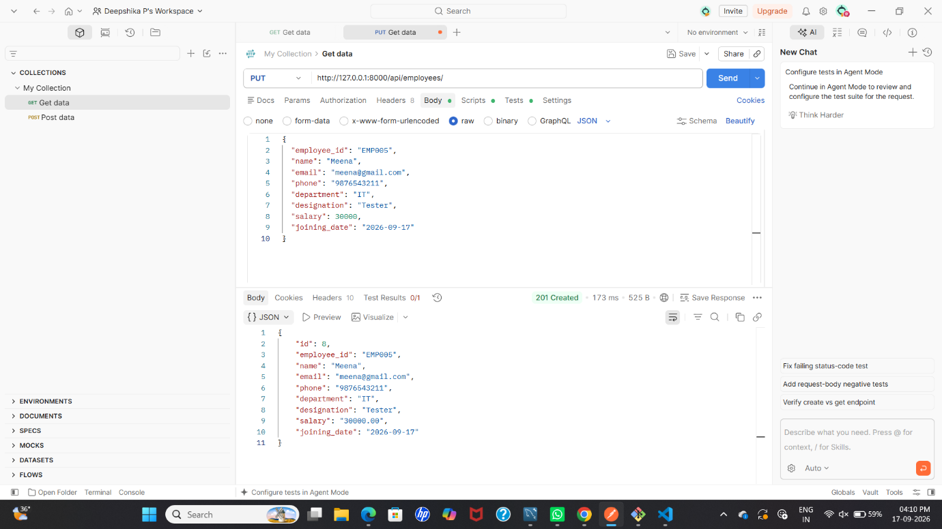
The screenshot shows the GET API request in Postman and the employee records returned from the Django REST API.

Figure 3 – POST Add Employee
The screenshot shows the POST request used to add a new employee and the successful response received from the API.

Figure 4 – PUT Update Employee

The screenshot shows the PUT request used to update employee information.

Figure 5 – DELETE Employee
The screenshot shows the DELETE operation performed on an employee record.

Figure 6 – GitHub Repository
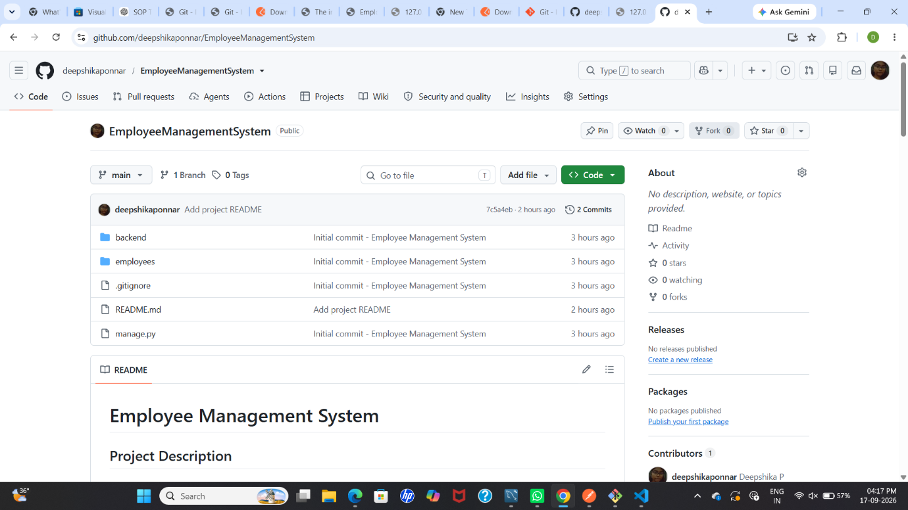
The screenshot shows the Employee Management System project repository containing the project files and README documentation.

22. GIT AND GITHUB
Git was used for version control during the development of the project.
The project was initialized as a Git repository and the source code was committed.
GitHub was used to store and share the project source code online.
The repository contains:
- Backend files
- Frontend files
- Django project files
- Employee application files
- README file
- .gitignore file
The project was successfully pushed to GitHub.

23. ADVANTAGES
The main advantages of the Employee Management System are:
- Easy employee record management.
- Simple and user-friendly interface.
- Reduces manual record keeping.
- Supports complete CRUD operations.
- Provides employee search functionality.
- Stores data in a database.
- REST API allows frontend and backend communication.
- Postman can be used for API testing.
- GitHub provides easy source-code management.

24. FUTURE ENHANCEMENTS
The project can be enhanced in the future with additional features such as:
- User login and authentication.
- Admin dashboard.
- Advanced employee filtering.
- Export employee data to Excel or PDF.
- Employee attendance management.
- Employee leave management.
- Profile photo upload.
- Cloud database integration.
- Deployment to a cloud server.
- Role-based access control.

25. CONCLUSION
The Employee Management System successfully demonstrates the development of a complete CRUD-based web application.
The frontend was developed using HTML, CSS, and JavaScript. Django and Django REST Framework were used to develop the backend REST API, while SQLite was used to store employee information.
The application provides important employee management features such as adding, viewing, searching, updating, and deleting employee records.
Postman was used to test the REST API operations, and Git and GitHub were used for version control and project hosting.
This project demonstrates the basic concepts of frontend development, backend development, database management, REST APIs, CRUD operations, API testing, and version control in a single web application.

